Approving Requisitions in Ariba Quick Reference Guide
Last Updated: 08/2023
This QRG provides the basic steps to review, edit, approve or deny a requisition. Full approval of a requisition is required to generate a Purchase Order (PO).
Fiscal Approvers will be added to the Requisition based on the Customer Department (cost center) and Requisition Amount. Approval flow noted below. Requsitions for $1K and less will not add a fiscal approver.
NOTE: Delegates are not to be assigned. Please work with the Master Data team if updates are needed to the workflow table to accommodate turnover and extended absences.
Fiscal Level | Requsition Amount | Fiscal Approvers
NA | $1,000 < | NA
Level 1 | $1,000.01 - $5,000 | 1
Level 2 | $5,000.01 - $25,000 | 2
Level 3 | $25,000.01 - $100,000 | 3
Level 4 | $100,000.01 - $500,000 | 3,4
Level 5 | $500,000.01 - $1,000,000 | 3,4,5
Level 6 | $1,000,000.01 - $2,000,000 | 3,4,5,6
 | $2,000,000.01 > | Board of Trustees approval obtained outside of Ariba. Level 6 will approve on BOT behalf.

Log-in to Ariba
Go to the OneCampus Portal.  Choose Procurement - Ariba to log in. | http://one.purdue.edu/  
Log in using your Purdue Career Account Username and Password.  Click Log in. | 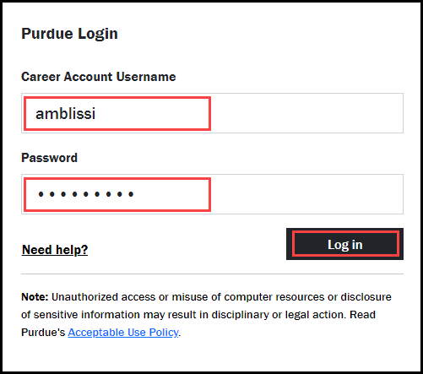

View All Requisitions in Ariba
On the Home Tab, to make sure you are seeing all the requisitions needing approval complete the following steps.
Click View All | 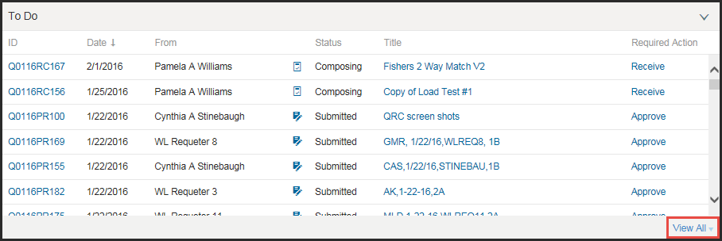
Click Approve | 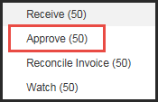
Select Approvable Type Requisition | 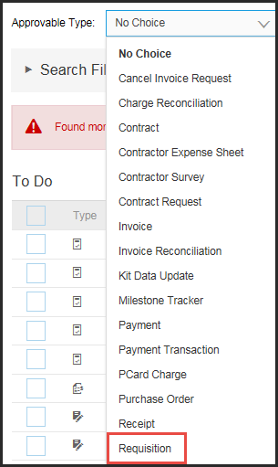
Click the arrow to expand the Search Filters | 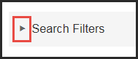
Chagne Date Created to No Choice | 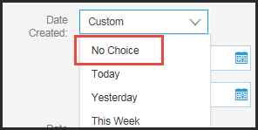
Click Search | 
Click on the ID number to open the requisition to review | 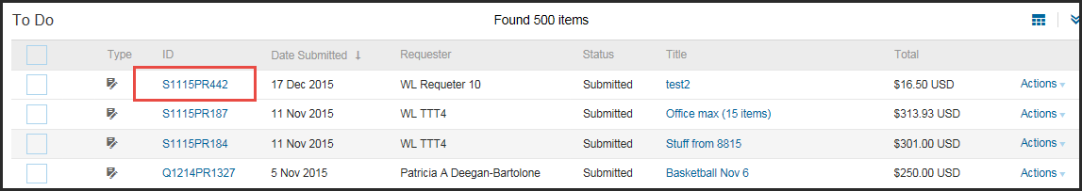
Editing a Requisition in Ariba before Approving
Once the requisition is open the approver has the options to approve, deny or edit.
Click Edit if any part of the line item information needs to be corrected. | 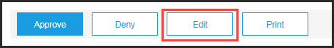
To edit account assignment, quantity, price, add or delete lines items, go to the Line Items section check the box next to the line or the top box for all lines needing an edit.  Click Edit.  NOTE: To Delete a line, click the check box for the line.  Then click Delete. | 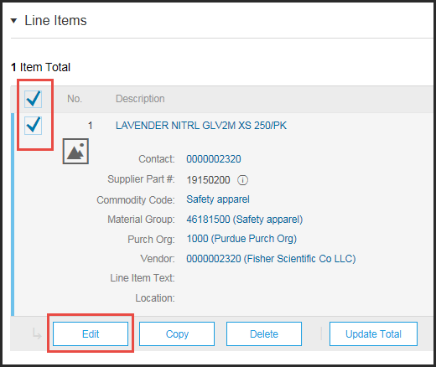
Change quantity, account assignment or ship-to information. | 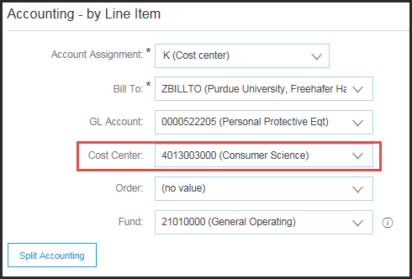  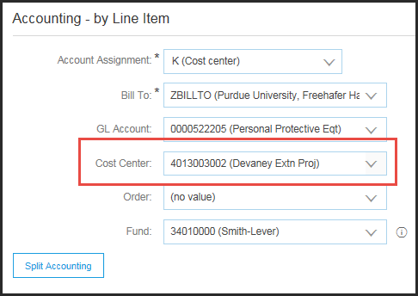
Once changes are complete click OK | 
To add a line item, click Continue Shopping to add an addition line.  Once all changes are finished Click Save, to save any changes made to requisition. | 
A Warning will appear, Ariba will re-draw the approval flow.  Click Save, to finish the edit.  By clicking Prev, user will be taken back to edit screen  By clicking Exit, user will be given options on how to proceed (such as Save this request, Undo any changes, Continue working on request and print a copy of request | 
Once an edit is saved, the Approver will need to return to the To Do list and click Approve again to go through the approval process for the appropriate requisition.

Approving in Ariba
Once the requisition is open the approver has the options to approve, deny or edit.
Review the Requisition:  Line item information the account assignment, approval flow and attachments etc.  Click Show Details to see additional information.  If non-catalog requisition, make sure pricing details (quote # or where rpicing come from) are in comments and visible to supplier to avoid invoicing issues later. | 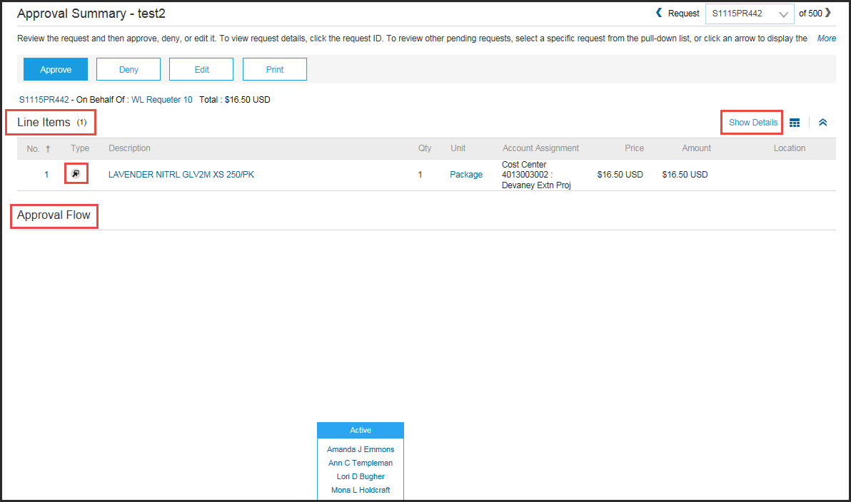
If requisition is correct, click Approve. | 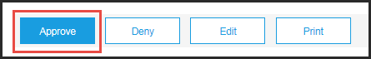
Add Comments if appropriate.  Check the box, beside go to next request to bring up the next item to be approved, if needed. | 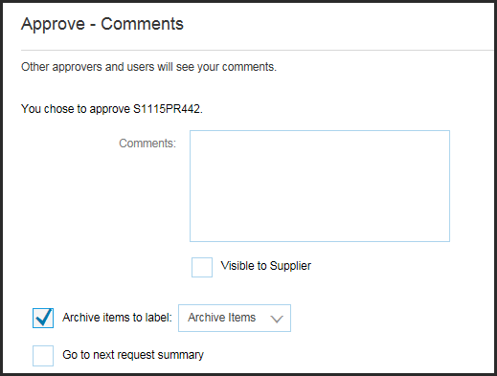
Click OK. | 
If the requisition needs to be returned to the requester, click Deny. | 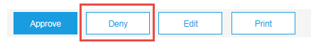
Enter Comments as to why the requisition was denied. | 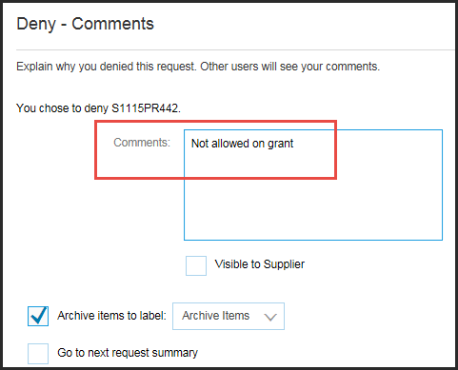
Click OK.
Click Logout | 
Approving from Email
NOTE: Email approvals should not be forwarded to others and are intended for the approver recipient of the email.
From the Email Notification, review the requisition summary. The same information available in Ariba can be viewed in the Email Notification, except attachments.  Click Approve or Deny to send an approval or denial to Ariba.  Click Open to view the requisition directly in Ariba and then follow the steps in the Approving in Ariba section above. | 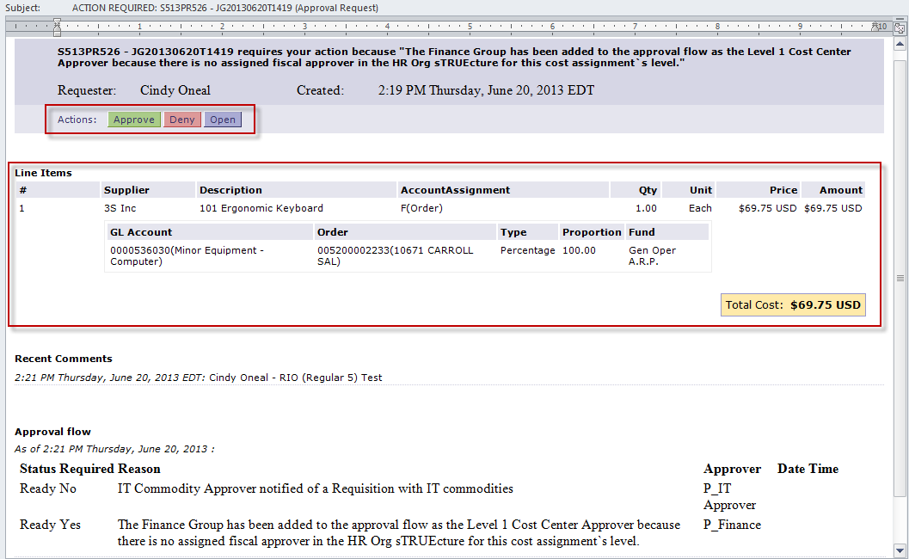
After clicking Approve or Deny, an email window will open.  Enter any desired comments between the two bracketed sections* (indicated with the red box), then click Send.  This will send the approval or denial to Ariba for electronic processing.  Note: DO NOT enter text outside of the bracketed sections, as this may cause issues with the electronic processing. | 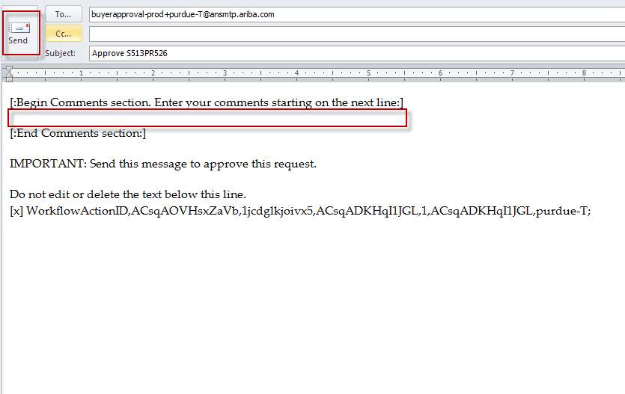
Approving from Smartphone
NOTE: Email approvals should not be forwarded to others and are intended for the approver recipient of the email.
Open the Email Notification from your Email application on your Smartphone device. From this message, you can review the requisition summary. The same information available in Ariba can be viewed in the Email Notification, except attachments  .  Tap or choose Approve or Deny to send an approval or denial to Ariba.  Tap or choose Open to view the requisition directly in Ariba.  Note: Viewing the requisition in Ariba from your mobile device may only work if Ariba allows access without being on the network. | 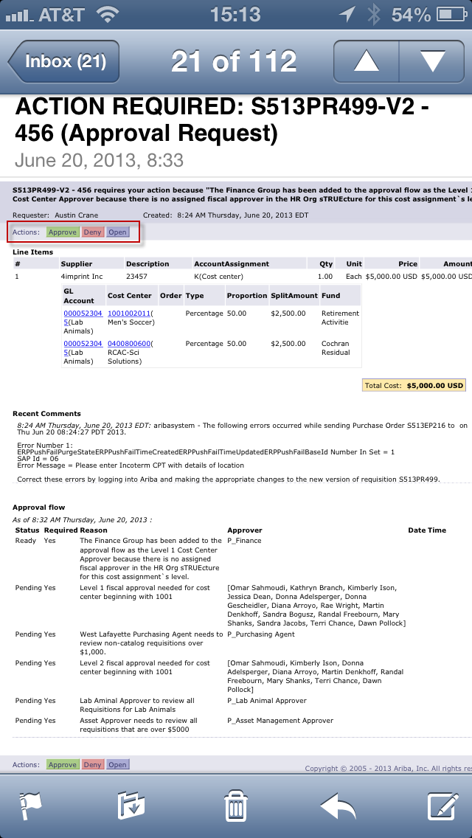
After tapping Approve or Deny, an email window will open.  Enter any desired comments between the two bracketed sections, and then tap Send.  This will send the approval or denial to Ariba for electronic processing.  Note: DO NOT enter text outside of the bracketed sections, as this may cause issues with the electronic processing. | 