Receiving in Ariba Quick Reference Guide
Last Updated: 03/05/2021
This QRC provides the basic steps to receive, reverse, return, reject and close a Purchase Order (PO) in Ariba. Receiving is required on PO’s greater than $1000. PO’s $1000 or less the auto-receipt will process at the end of the lead-time. For non-catalog items the lead time is 5 days. For catalog items, the lead time for each item is set by the vendor.
Please note that documentation is to be retained on file that the item(s) were received, regardless of auto-receive threshold.
Jump Links: Access Ariba, Receive, Attach Packing Slip, Reversal, Return, Cancel/Close

Access Ariba
Visit the OneCampus Portal and select Procurement – Ariba. | https://one.purdue.edu/  
Log in using Purdue Career Account ID and BoilerKey passcode. | 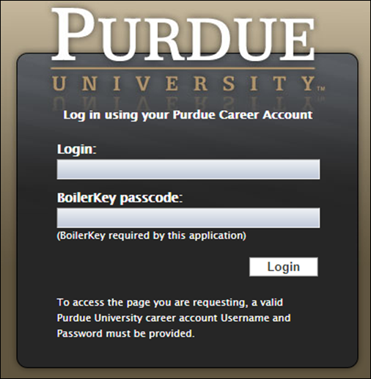

Receive
Receiving indicates that the goods or services ordered were received from the supplier, and that the supplier should receive payment.
A receipt is required by a receiver when the PO total is greater than $1000.
A packing slip should be used as the back-up documentation for the receipt. Attach the packing to the receipt when processing. If the receipt has already been processed, attach the packing slip to the PO.

Search for Receipt
From the Manage drop-down, select Receive. | 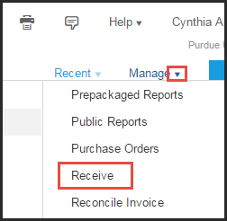
Enter PO number in the Order ID field.  Click the Needs receiving radio button.  Click Search.  PO’s will begin with a “45”.  If the PO is not found, click the All radio button and execute search again.  NOTE: A search can be executed using other IDs, simply choose an alternate document type from the drop-down menu and enter corresponding data into the search text entry box. | 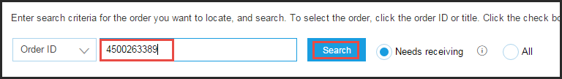
For a 2-way match PO no results will be found, even when the all button is selected. | 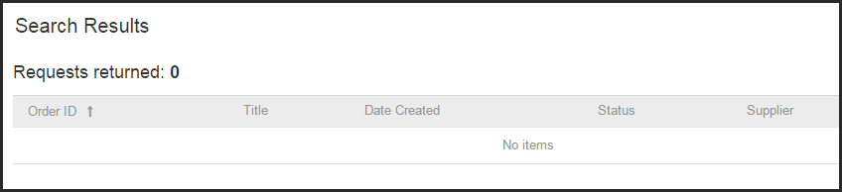
For a 3-way match PO, if the PO needs receiving the receipt will appear in the search results.  Click the Order ID/PO Number to view receipt. | 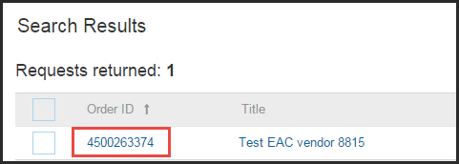

Full Receipt
Click Accept All at the top of the screen. | 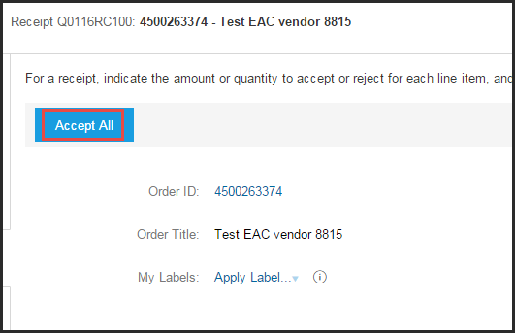
Verify the Accepted field has the correct quantity listed for each line item. | 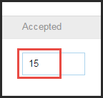
Click Yes to Close Order. | 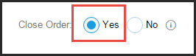
Use the calendar icon to select the Date the items were physically received. | 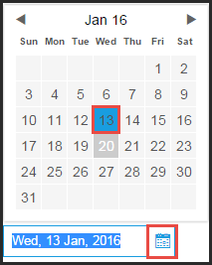
Click Submit. | 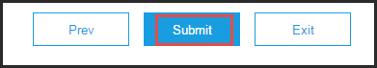

Partial Receipt – Remaining Items Expected
If a partial quantity of a line was physically received then enter the quantity on the line item in the Accepted Field.  Repeat this step for each line item of the PO that items have been physically received. | 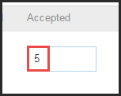
In the Close Order field, click the No radio button, as remaining items are still expected.  Enter Comments, if desired. | 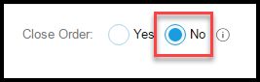
Click Submit.
Click Submit again. | 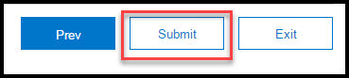
In order for the receipt to be approved, the receiver must submit the receipt a second time for this scenario. If this step is not completed the receipt remains in composing status.  Click Select. | 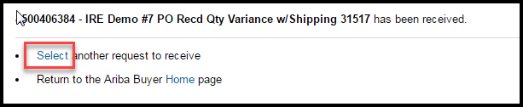
Click Submit. | 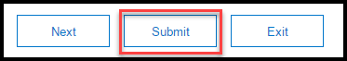

Partial Receipt – Cancel Remaining Items
If a partial quantity of a line was physically received then enter the quantity on the line item in the Accepted Field.

Repeat this step for each line item of the PO that items have been physically received.
If no other items will be physically received on the PO click the Yes radio button to Close Order if the PO is complete.
Click Submit.

Attach Packing Slip
Packing slips are required for all purchases, regardless of dollar amount. They should be scanned and attached when processing the receipt.
Click Add Attachment. | 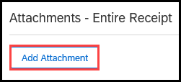
Click Browse. | 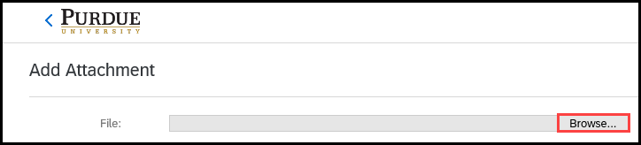
Find file and click to select.  Click Open. | 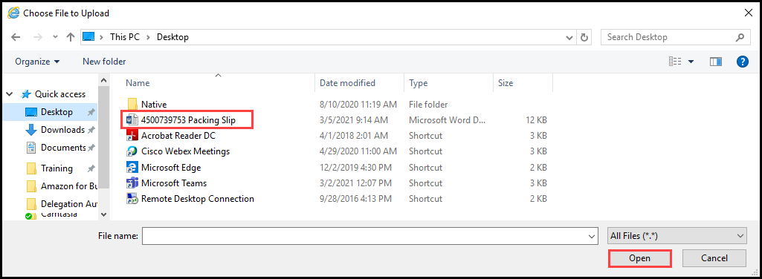
File extension is displayed. | 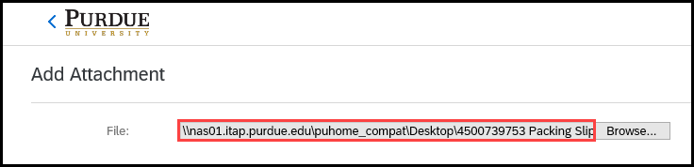
Click OK. | 
The file is listed under the Attachment header of the receipt. | 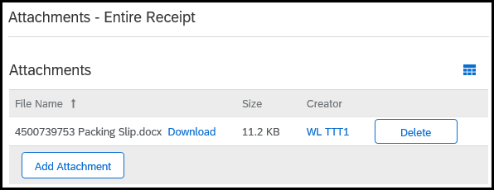

Reversal
If an item(s) was/were not physically received from the vendor and an auto-receipt posted or someone processed a receipt in error, check the Prev. Accepted field to see if a receipt was processed already.
After a receipt has been processed, either an auto-receipt or by an Aria receiver, a negative number entered in the accepted field will “reverse” the previously processed receipt. This often occurs when an auto-receipt is processed and the vendor, for a variety of reasons, does not fill the PO.

Reversal of Receipt
Enter a negative quantity in Accepted field for items not physically received. | 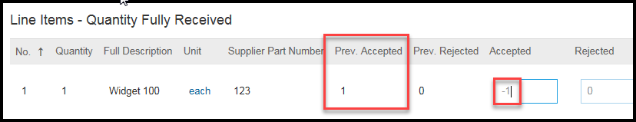
In the Close Order field, select:  - No, if items will be sent for this PO.  - Yes, if items will not be sent for this PO.  NOTE: If Close Order – No is selected the receipt will have to be submitted a second time or the receipt will stay in composing status and be processed. | 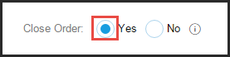
Click Submit. | 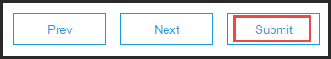

Return
Items are physically sent back to the vendor. This is recorded is the Rejected field. Only when items are physically sent back to the vendor, should there be a quantity recorded in this field.

Return – Receipt Not Processed
Enter the quantity in Rejected field for items being returned. | 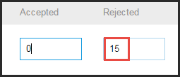
In the Close Order field, select:  - No, if replacements items will be sent under this PO.  - Yes, if no replacement items will be sent under this PO.  Enter the Return Authorization Number from the supplier | 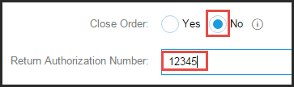
Click Next. | 
Enter the Rejection Reason or the reason the items were being returned.  In the Return By field, select:  - Replacement if the items were damaged and new items are expected.  If No to Close Order was selected on the previous page then select this option.  - Credit if the items are being sent back and no items will be sent for this PO.  If Yes to Close Order was selected on the previous page than select this option. | 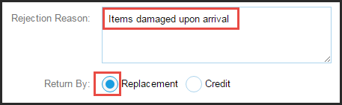
Click Next. | 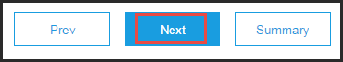
Click Submit. | 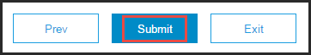

Return – Receipt Processed
If an item or items need to be returned after a receipt has been completed either by auto-receipt or a receiver.
Click Reopen Order. | 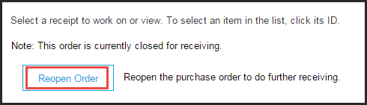
For a return that has previously accepted items, enter a negative number in the Accepted field and enter a positive number in the Rejected field. | 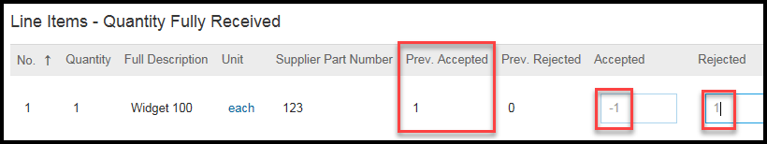
In the Close Order field, select:  - Yes if the same items will not be sent as a replacement on this PO.  - No if the same replacement items will be physically received.  Enter the Return Authorization Number given by the supplier. | 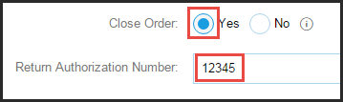
Click Next. | 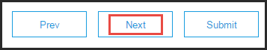
Enter the Rejection Reason or the reason the items are being returned.  In the Return By field, select:  - Replacement if the items were damaged and new items are expected.  If No to Close Order was selected on the previous page then select this option.  - Credit if the items are being sent back and no items will be received for this PO.  If Yes to Close Order was selected on the previous page than select this option. | 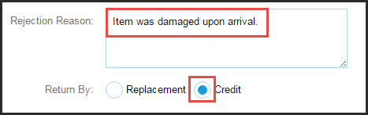
Click Next. | 
Click Submit. | 

Cancel/Close
If the PO has been canceled with the vendor via a phone call or email; follow these steps to close the PO in Ariba.

Cancel/Close PO
Previously accepted should be zero. If there is a quantity here, go to the Reversal section and follow those steps.  Leave quantity as zero for each line item. | 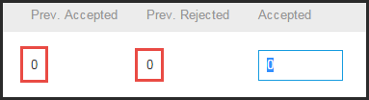
In the Close Order field, select the YES radio button. | 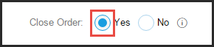
Click Submit. | 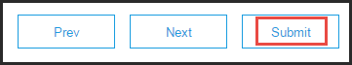

Cancel/Close PO - Partial
If the PO line items have been canceled with the vendor via a phone call or email; follow these steps to close the remaining items on the PO in Ariba.
If all quantities that have been physically received have not yet been received in Ariba, go to the Partial Receipt – Cancel Remaining Items section.  Leave quantity Accepted as zero for each line item to close.  NOTE: All other items need to be received in Ariba before closing the PO. | 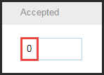
In the Close Order field, select the YES radio button. | 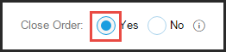
Click Submit. | 